CSA1616 - DATA WAREHOUSING AND DATA MINING
WEKA Lab Experiments
Name: Pravin R
Reg. No: 192421292
Date: 03/11/2026

Experiment - 22
Aim:
To show data set and perform the Apriori Algorithm and FP algorithm.
Code:
@relation market_transactions
@attribute a {0,1}
@attribute b {0,1}
@attribute c {0,1}
@attribute d {0,1}
@attribute e {0,1}
@data
1,0,0,1,1 % 0001 → {a,d,e}
1,1,1,0,1 % 0024 → {a,b,c,e}
1,1,0,1,1 % 0012 → {a,b,d,e}
1,0,1,1,1 % 0031 → {a,c,d,e}
0,1,1,0,1 % 0015 → {b,c,e}
0,1,0,1,1 % 0022 → {b,d,e}

0,0,1,1,0 % 0029 → {c,d}
1,1,1,0,0 % 0040 → {a,b,c}
1,0,0,1,1 % 0033 → {a,d,e}
1,1,0,0,1 % 0038 → {a,b,e}

Output:
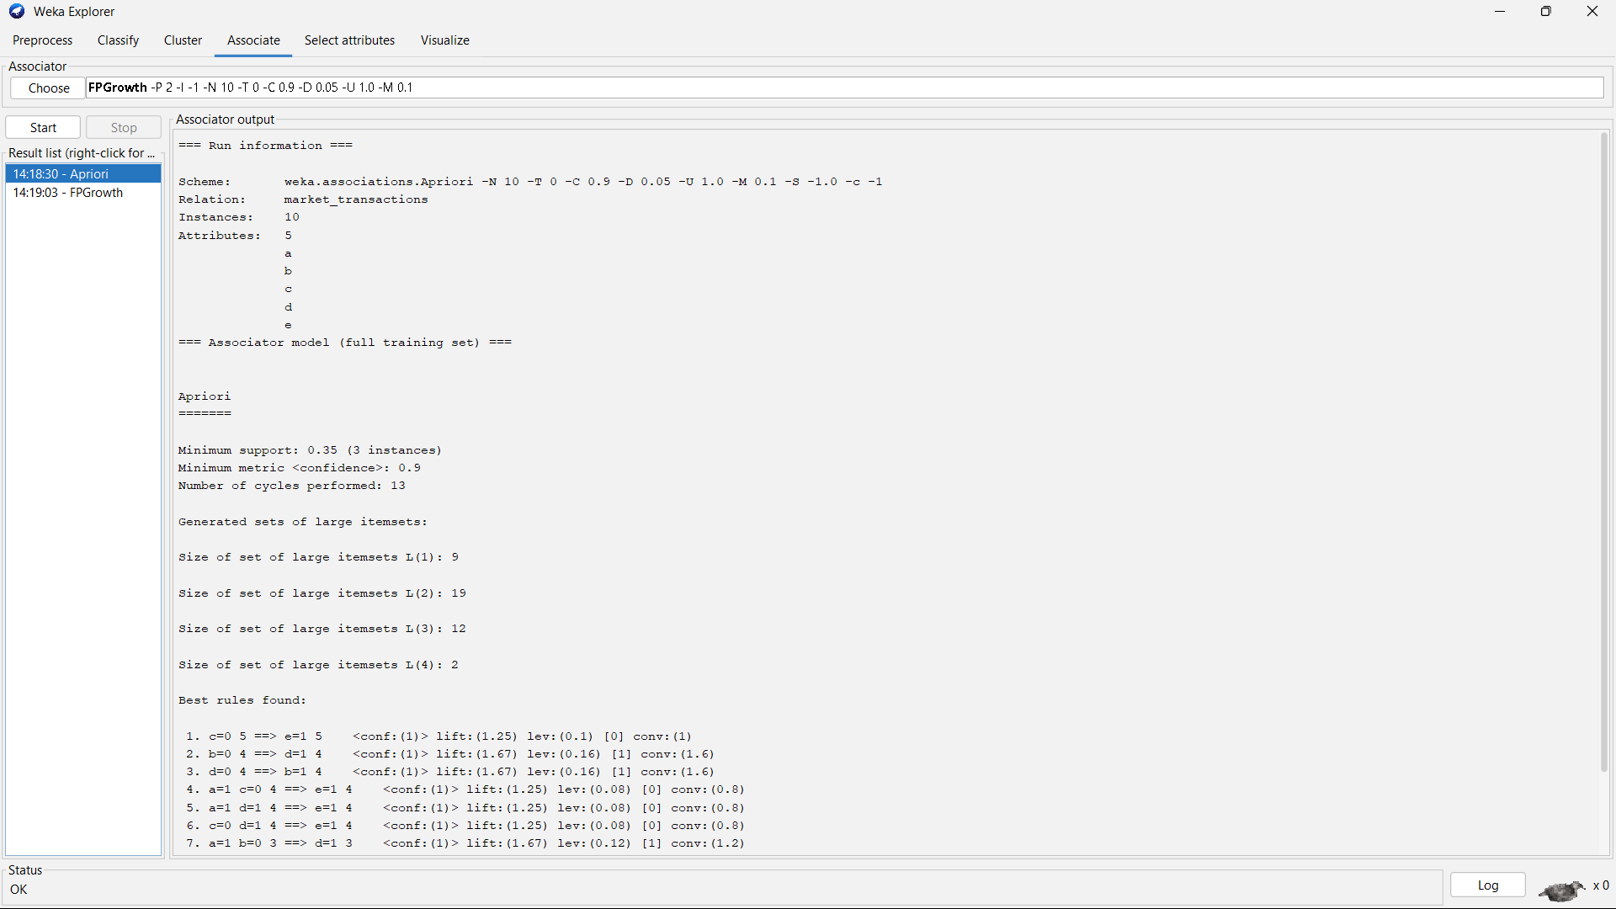
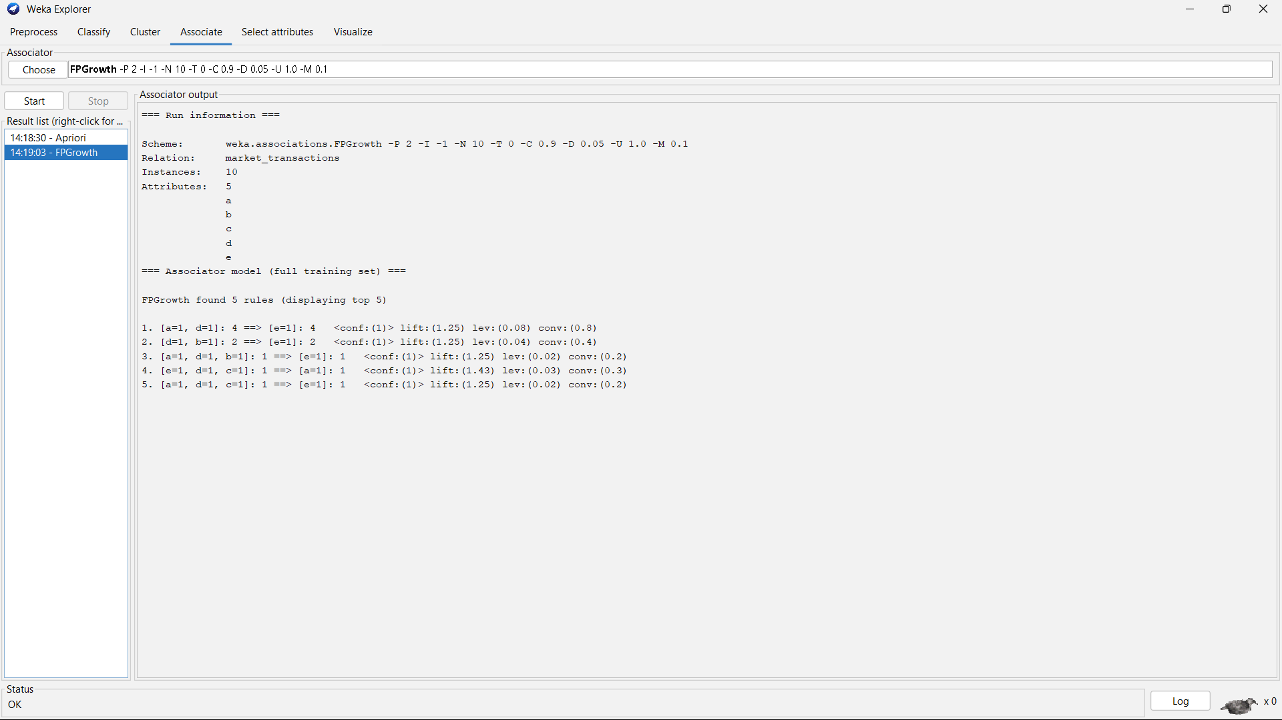
Result:
It is executed successfully.

Experiment - 23
Aim:
To show data set and perform the Apriori Algorithm and FP algorithm.
Code:
@relation market_basket
@attribute Milk {yes,no}
@attribute Bread {yes,no}
@attribute Butter {yes,no}
@attribute Eggs {yes,no}
@attribute Cheese {yes,no}
@data
yes,yes,no,yes,no
no,yes,yes,no,yes
yes,no,yes,yes,no
yes,yes,yes,no,yes
no,no,yes,yes,no
Output:
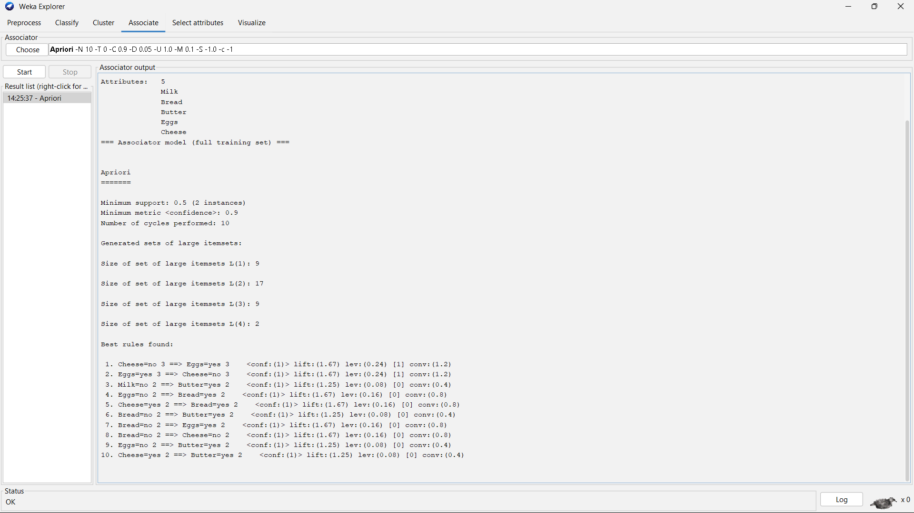
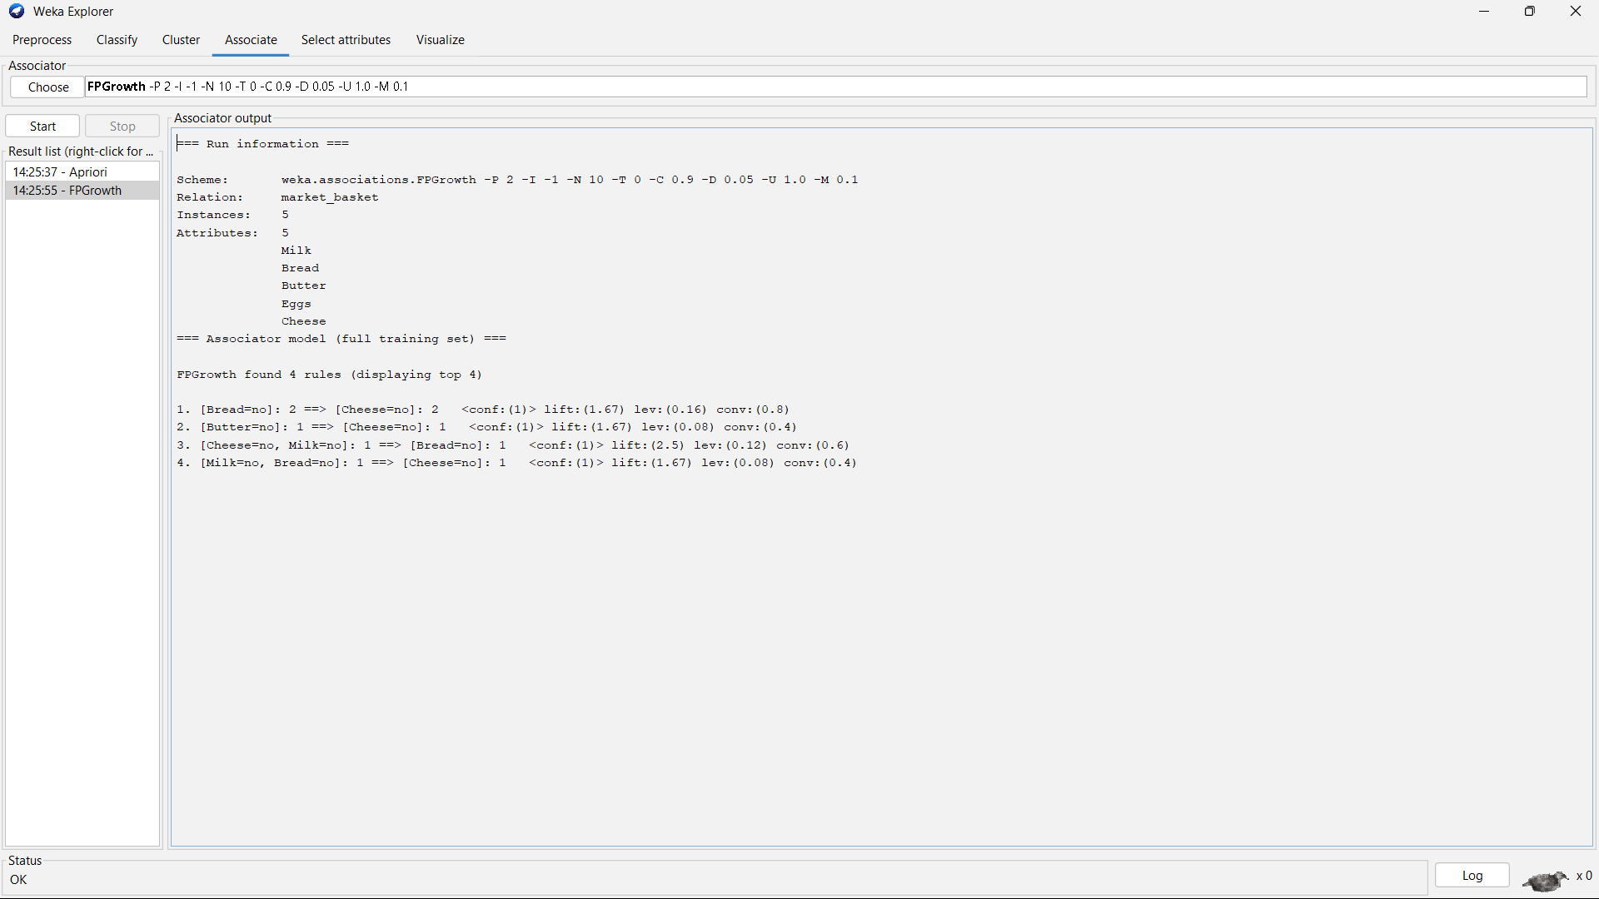
Result:
It is executed successfully.

Experiment - 24
Aim:
To show Bayes classification and descion tree.
Code:
@relation buy_computer
@attribute age {youth,middle_aged,senior}
@attribute student {yes,no}
@attribute credit_rating {fair,excellent}
@attribute buys_computer {yes,no}
@data
youth,no,fair,no
youth,no,excellent,no
middle_aged,no,fair,yes
senior,yes,fair,yes
senior,yes,excellent,no
senior,no,excellent,yes
middle_aged,yes,excellent,yes
youth,no,fair,no
youth,yes,fair,yes
senior,yes,fair,yes
youth,yes,excellent,yes
middle_aged,no,excellent,yes
middle_aged,yes,fair,yes
senior,no,fair,no

Output:
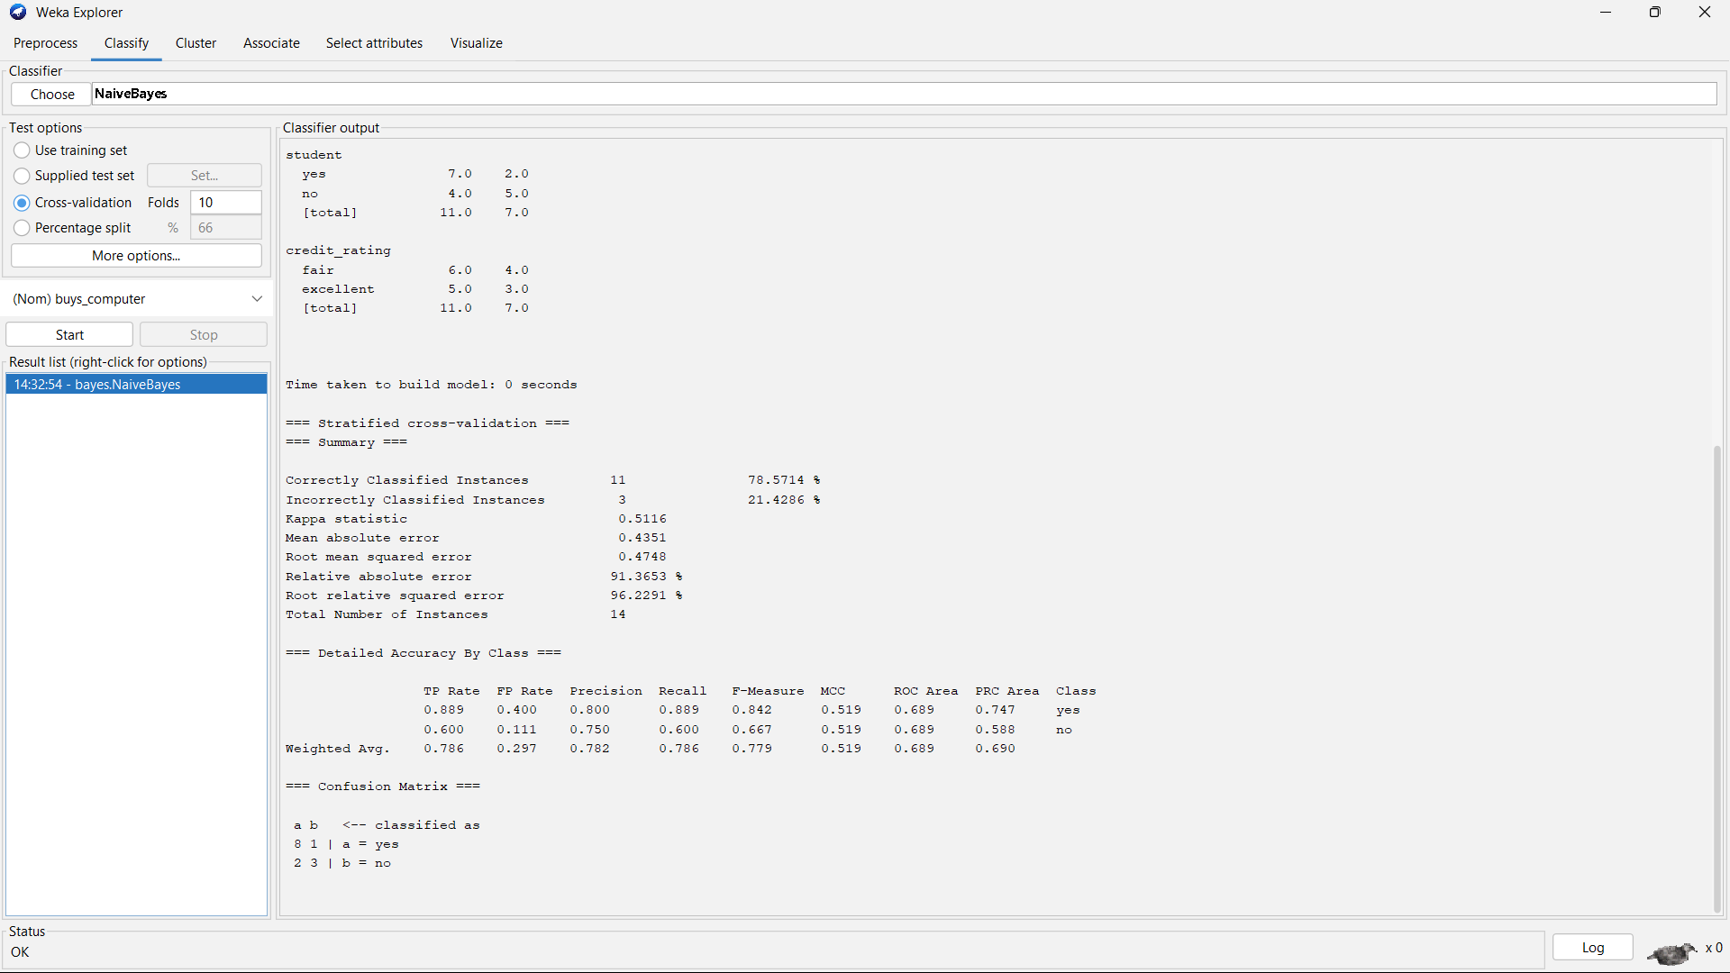
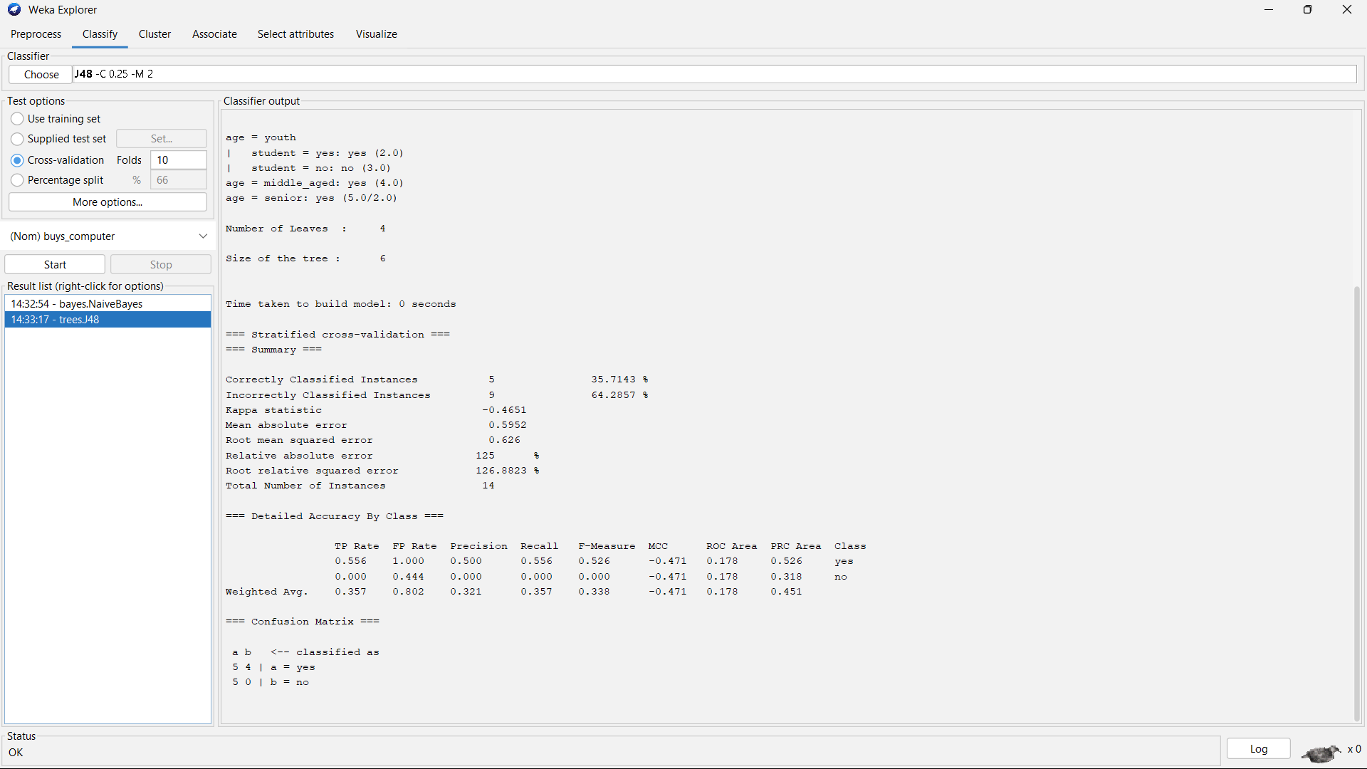
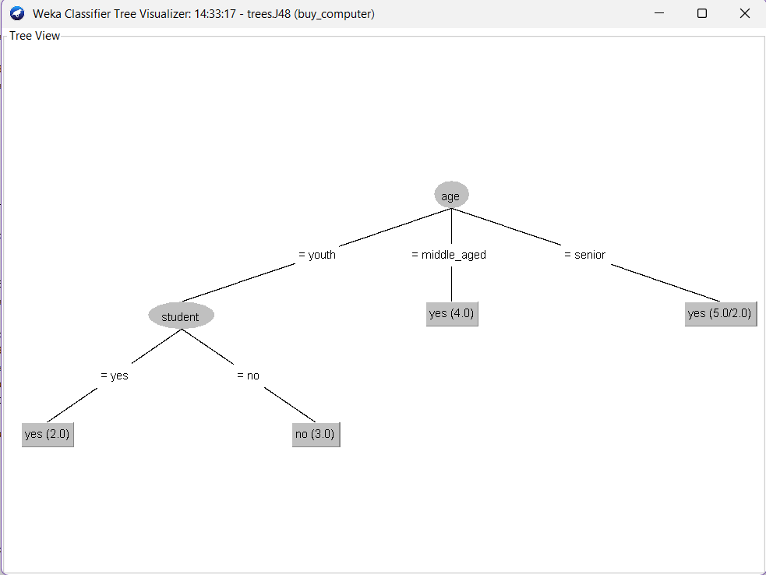

Result:
It is executed successfully.

